Project Documentation
Documentation
Date | 02 October 2026
Student Name | Dhanyaa V S
Project Name | Automated Network Request Management in ServiceNow

1. Introduction & Project Overview
In traditional enterprise IT setups, handling network requests—such as setting up a new line, changing bandwidth, or updating connection settings—often relies on manual emails, paper slips, or scattered chat messages. This manual way of working causes unnecessary delays, missing details, untracked manager approvals, and potential security oversights.
To solve these operational problems, I developed the ‘Automated Network Request Management’ system on the ServiceNow cloud platform. As an individual developer, I configured and connected the entire end-to-end lifecycle: creating a dedicated Service Portal intake form, setting up dynamic Catalog UI Policies to keep data accurate, persisting data in a custom table Database Tables (u_database_tables) with the prefix ‘NETDB’, automating approvals and status updates using a 10-step Flow Designer workflow, and triggering automated email notifications. This implementation manual documents the exact steps I followed to build, configure, and verify this automated solution.

2. Stage 1: Custom Relational Schema Configuration (Database Tables)
To isolate network operational records from standard incident queues and support structured data retention, I created a custom table named &#39;Database Tables&#39; (u_database_table) with dedicated business columns and auto-numbering configured with the prefix ‘NETDB’
Steps I followed:
1. I navigated to All > System Definition > Tables and clicked New.
2. I set the Table Label to ‘Database Tables’, and ServiceNow auto-generated the system name ‘u_database_table’.
3. Under the Controls tab, I checked ‘Auto-number’, specified the Prefix as ‘NETDB’, and configured 7 digits so requests generate identifiers in the format NETDB0001001.
4. Under the Columns section, I defined the custom schema fields outlined in Table 1 below.
5. I saved the table configuration and validated the generated default Access Control Lists (ACLs).

Screenshot 1: Custom Table Dictionary Schema (sys_db_object)

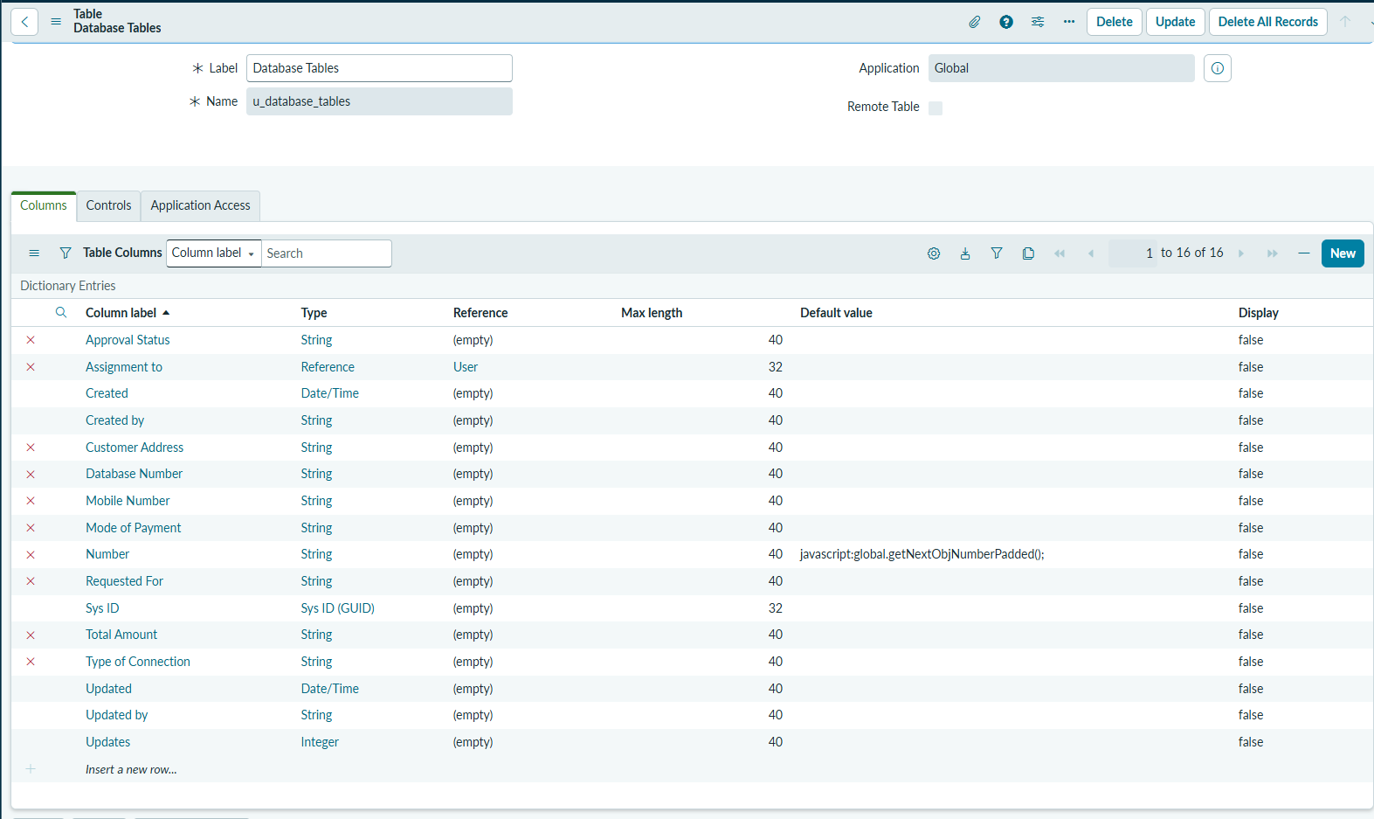

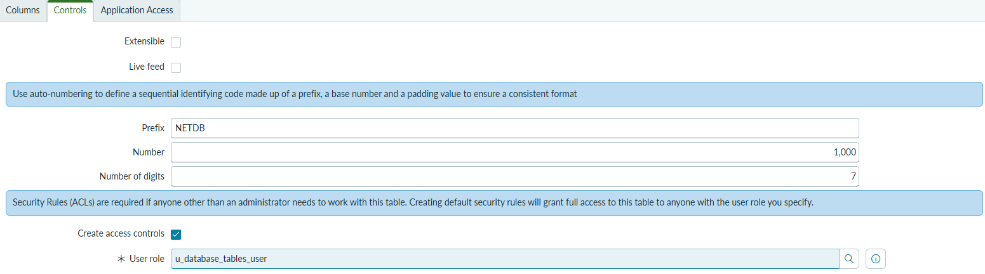

Purpose: Validates the custom database schema structure, column types, and auto-number setup.
What I Captured: I opened System Definition > Tables > ‘Database Tables’ (u_database_tables) and captured the Columns list displaying my custom fields alongside the Auto-Number prefix ‘NETDB’.

3. Stage 2: Service Catalog Intake & Dynamic UI Policy Configuration
Next, I configured the self-service catalog item within the Service Catalog and implemented dynamic client- side visibility logic to keep the user interface clean and prevent incomplete submissions.
Steps I followed:
1. I navigated to Service Catalog > Catalog Definitions > Maintain Items and created a new Catalog Item.
2. I set the Name to ‘Network Request’ and assigned it to the category ‘Network request Management’.
3. In the Variables related list, I created all the intake variables corresponding to my database columns.
4. To handle conditional visibility, I opened the Catalog UI Policies related list and clicked New.
5. I configured the UI Policy condition as: ‘Type of Connection is Existing’, setting ‘On Load’ to True and ‘Reverse if false’ to True.
6. In the Catalog UI Policy Actions related list, I created an action targeting the ‘Existing ID’ variable with Make Visible = True and Make Mandatory = True.

Screenshot 2: Service Catalog Item Backend Configuration
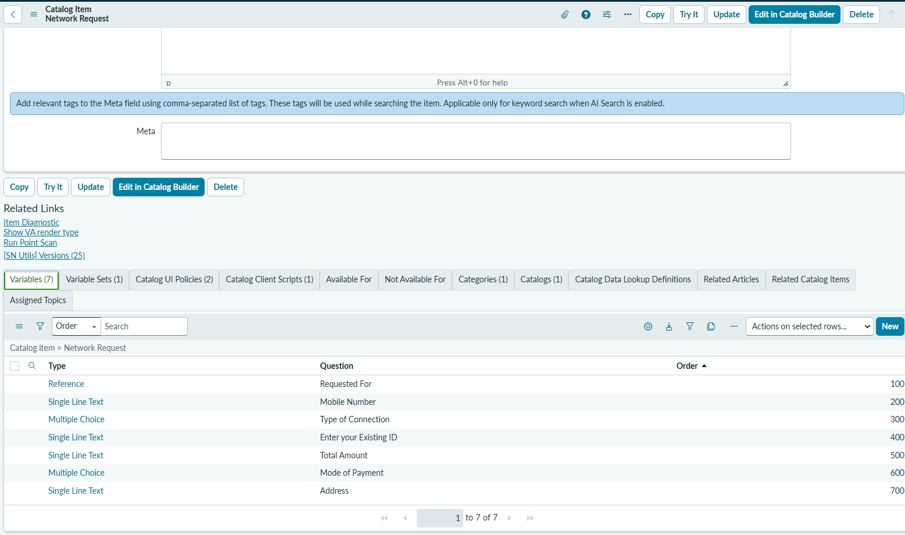

Purpose: Shows administrative catalog item configuration, variables list, and category alignment.
What I Captured: I navigated to Service Catalog > Maintain Items > ‘Network Request’ and captured the catalog item header, category selection, and the Variables related list displaying all the configured variables.

Screenshot 3: Dynamic Catalog UI Policy Configuration
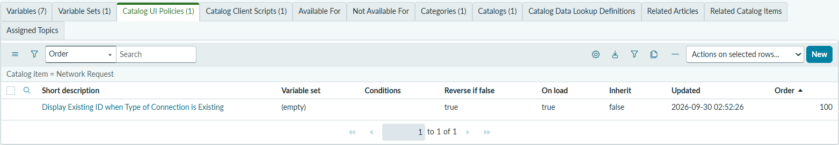

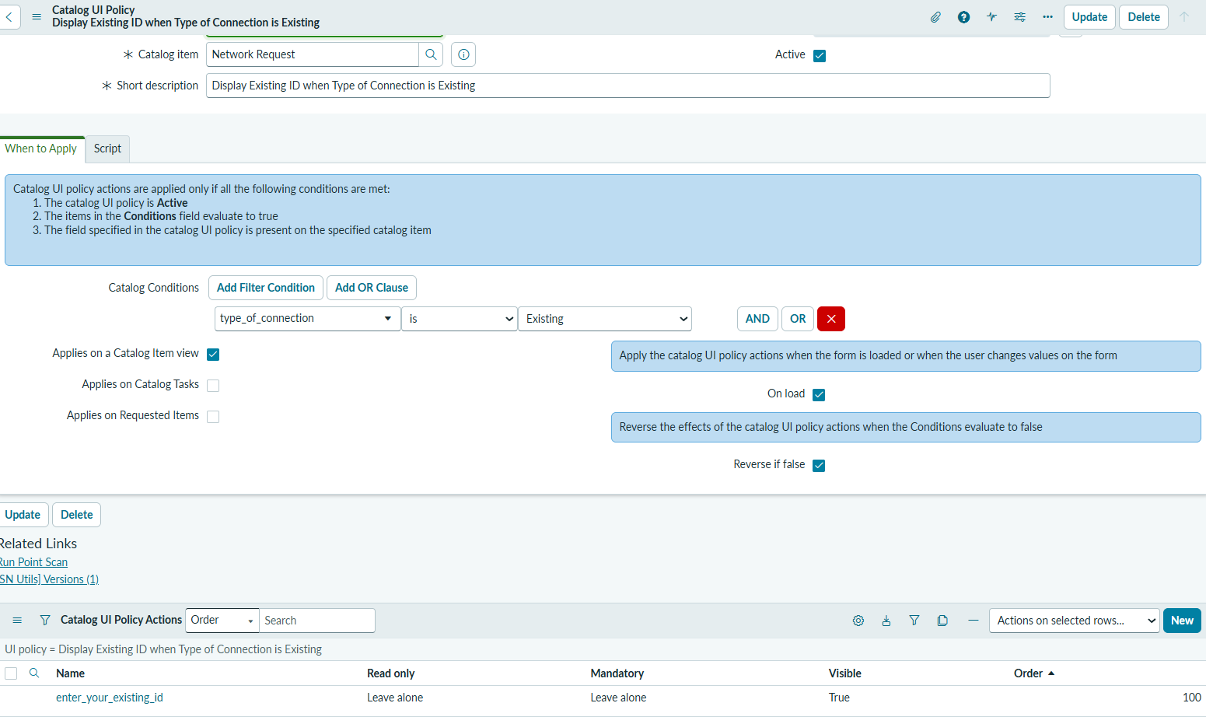

Purpose: Proves declarative condition logic driving conditional field display.
What I Captured: I opened the Catalog UI Policy record for ‘Network Request’ and captured the condition builder (‘Type of Connection is Existing’) along with the Catalog UI Policy Action making ‘existing_id’ visible and mandatory.

4. Stage 3: Service Portal User Intake Walkthrough (/sp)
To test the requester interface, I simulated the end-user submission experience directly on the ServiceNow Service Portal.
Steps I followed:
1. I logged into the Service Portal via: https://dev425212.service-now.com/sp.
2. I entered ‘Network Request’ into the global search bar to confirm discoverability.
3. I opened the catalog item and reviewed the layout containing user contact, billing, and address fields.
4. I toggled the ‘Type of Connection radio button to ‘Existing’ to verify that the ‘Existing ID’ input field displayed dynamically.
5. I populated all mandatory fields, selected the Mode of Payment (UPI / Card), specified the Total Amount, entered the delivery Address, uploaded a test attachment, and clicked Submit.

Screenshot 4: Service Portal Catalog Search
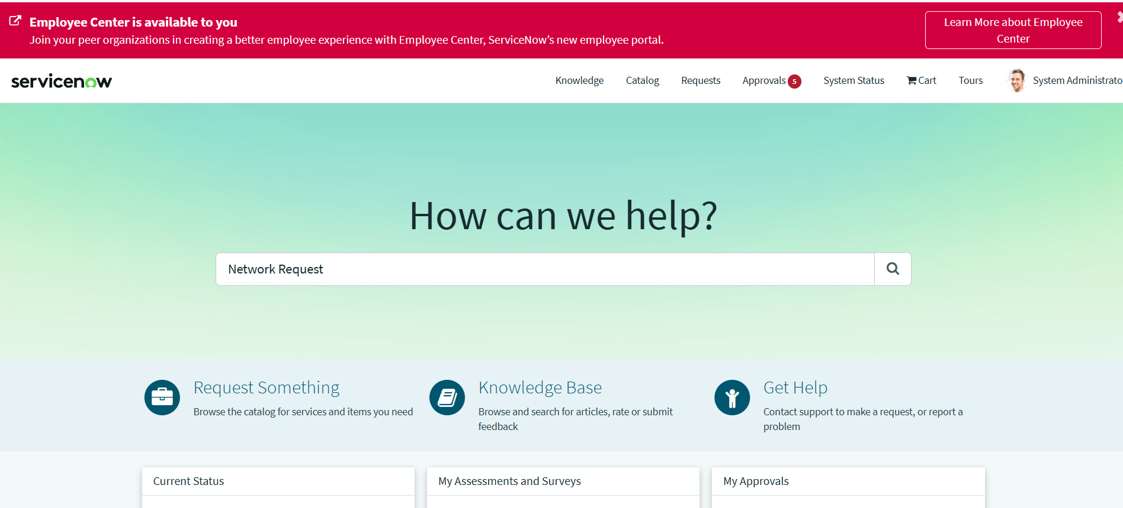

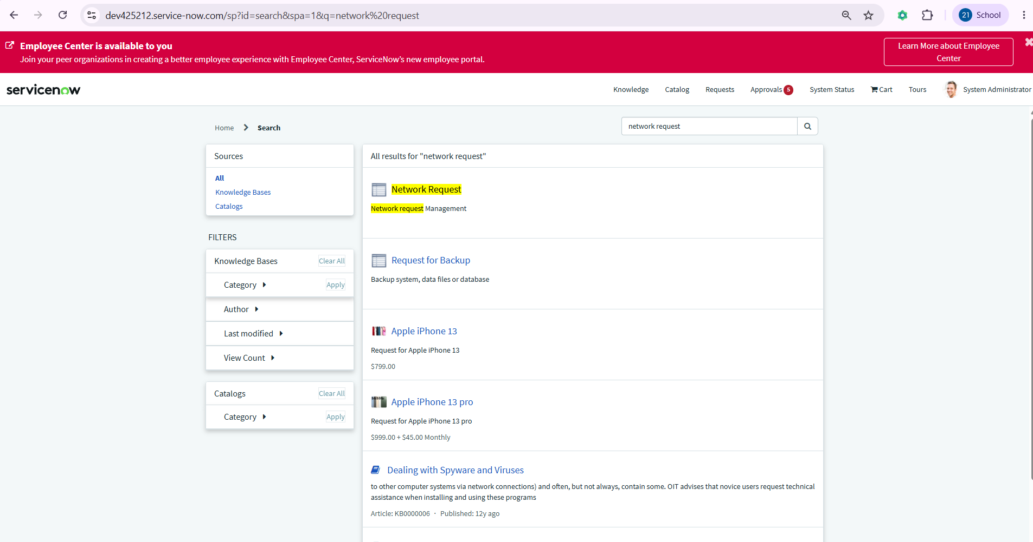

Purpose: Shows end users discovering the Network Request catalog item within the self-service portal.
What I Captured: I navigated to /sp, typed ‘Network Request’ into the search box, and captured the catalog item result appearing under ‘Network request Management’.

Screenshot 5: Network Request Catalog Form (Intake View)
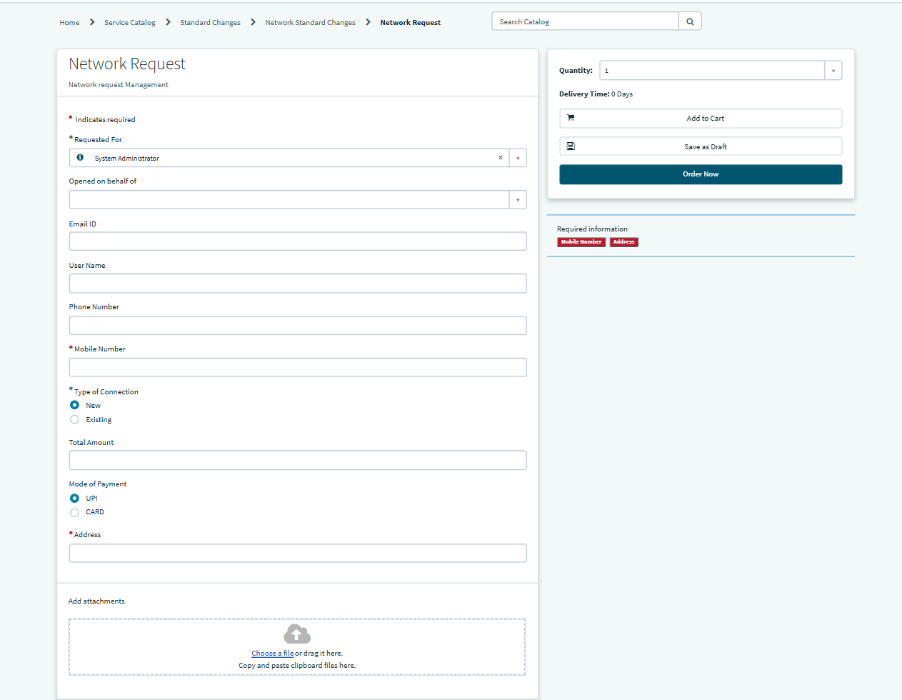

Purpose: Displays the active catalog form capturing user contact, connection type, payment mode, and address.
What I Captured: I opened the form on /sp and captured the full intake screen with Requested For, contact info, Type of Connection
(New/Existing), Total Amount, Mode of Payment (UPI/Card), Address, and the file attachment area.

Screenshot 6: Dynamic UI Policy in Action (Existing ID Conditional Field)
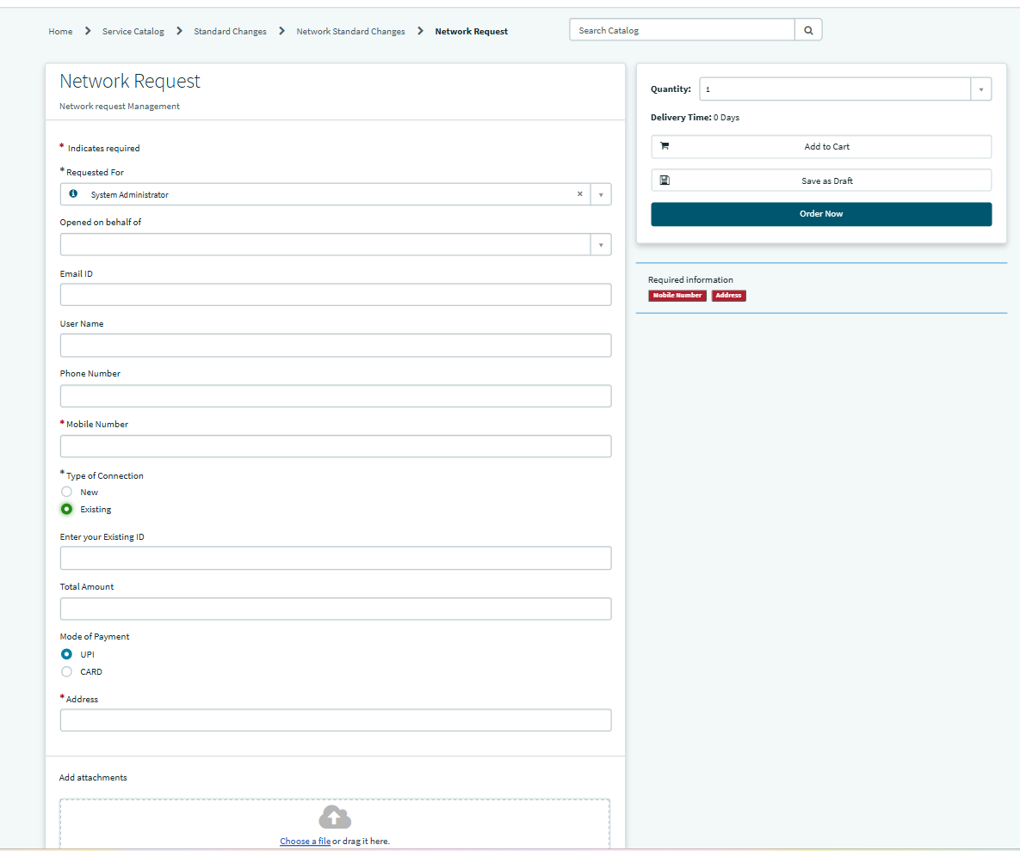

Purpose: Demonstrates client-side dynamic UI policy execution revealing the 'Existing ID' field when 'Existing' is selected.
What I Captured: On the portal form, I clicked the Existing radio choice and captured the screen showing the mandatory Existing ID field dynamically appearing without a page refresh.

Screenshot 7: Request Submission Summary (Order Confirmation
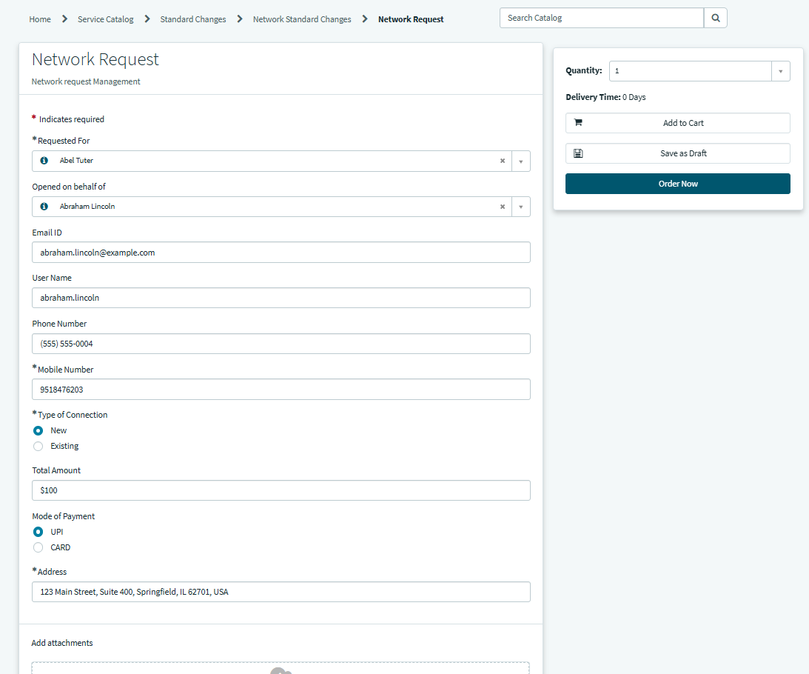

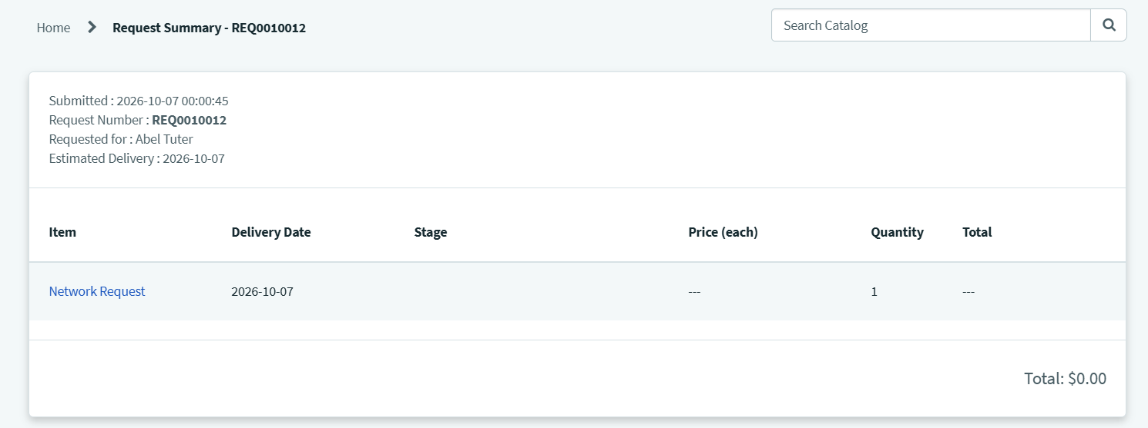

Purpose: Shows the portal order confirmation screen confirming successful request generation.
What I Captured: I clicked Submit and captured the resulting confirmation screen displaying the generated Request Number ( REQ... / RITM... ) and timestamp.

Stage 4: Flow Designer 10-Step Workflow Construction
To automate the entire request lifecycle without writing custom scripts, I built a zero-code workflow in ServiceNow Flow Designer / Workflow Studio.
Steps I followed to configure the 10-step flow:
- Trigger: I configured the trigger as Service Catalog so the flow fires automatically upon form submission.
- Step 1 (Get Catalog Variables): I added the Get Catalog Variables action, pointed it to the 'Network Request' catalog item, and pulled all form variables into data pills.
- Step 2 (Create Record): I added the Create Record action targeting Database Tables ( u_database_tables). I mapped all incoming catalog data pills to the table fields and set State = Awaiting Approval.
- Step 3 (Send Email): I added the Send Email action targeting the created Database Tables record to send an instant acknowledgment email to the requester containing the NETDB tracking ID.
- Step 4 (Ask For Approval): I added the Ask For Approval action on the Database Tables record, setting the rule to approve when Anyone approves and targeting the designated manager.
- Step 5 (If Condition): I configured an If condition evaluating: Step 4 Ask For Approval > Approval State is Approved.
- True Branch (Steps 6 & 7): Under the True condition, I added Step 6 Update Record to change State to Approved, followed by Step 7 Send Email to deliver an approval notification.
- False Branch (Steps 9 & 10): Under the Else condition, I added Step 9 Update Record to change State to Rejected, followed by Step 10 Send Email to deliver a rejection notification.
- I clicked Save, executed a test run using Test Flow, and activated the workflow.

Screenshot 8: Flow Designer 10-Step Workflow Execution Canvas
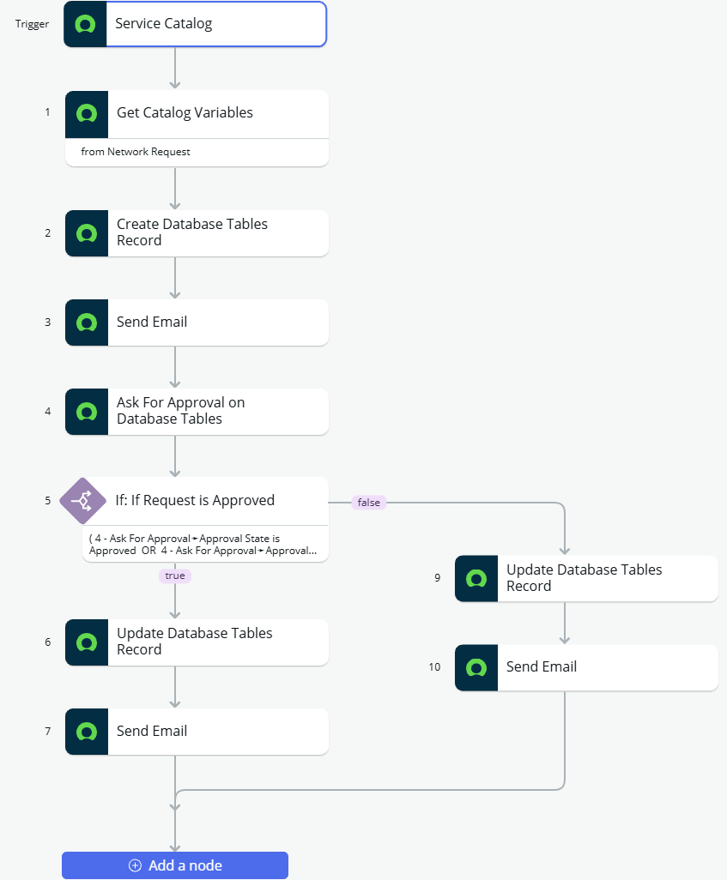

Purpose: Proves end-to-end low-code workflow logic in ServiceNow Workflow Studio.
What I Captured: I opened Flow Designer for Network Request and captured the complete workflow canvas showing the Trigger, Steps 1 to 4, the Step 5 If logic, and both execution branch paths.

Screenshot 9: Flow Execution Details (Runtime Traces & Logs)
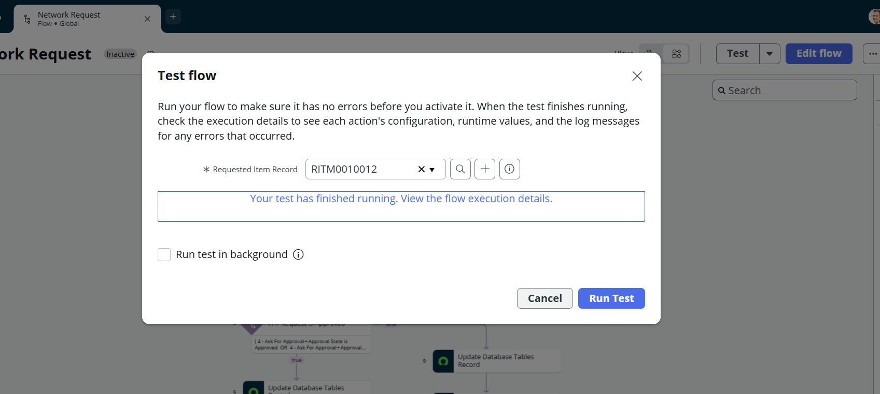

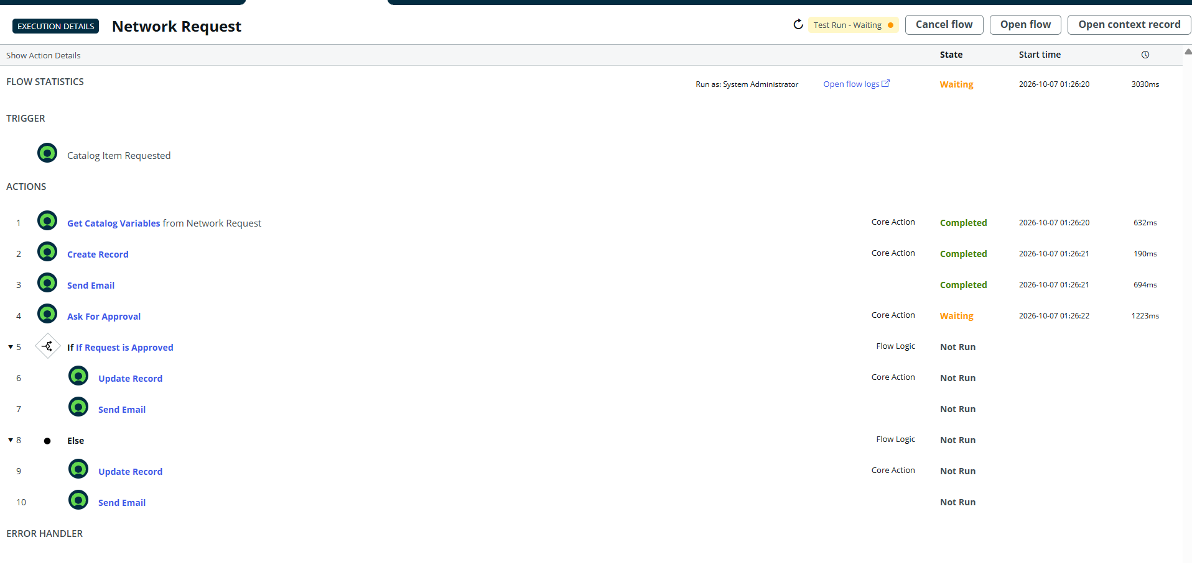

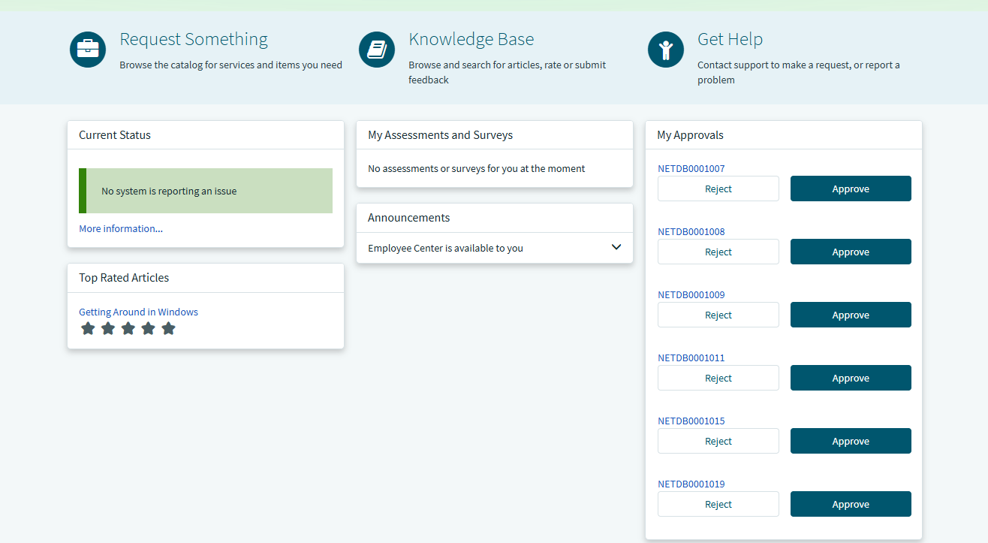

Purpose: Confirms runtime execution success and data pill variable parsing without errors.
What I Captured: I opened the Flow Execution Details for my test submission and captured the execution trace showing green checkmarks across all evaluated steps.

Screenshot 10: Flow Execution Details (Post-Approval Resumption - State: Completed / True Branch Executed)
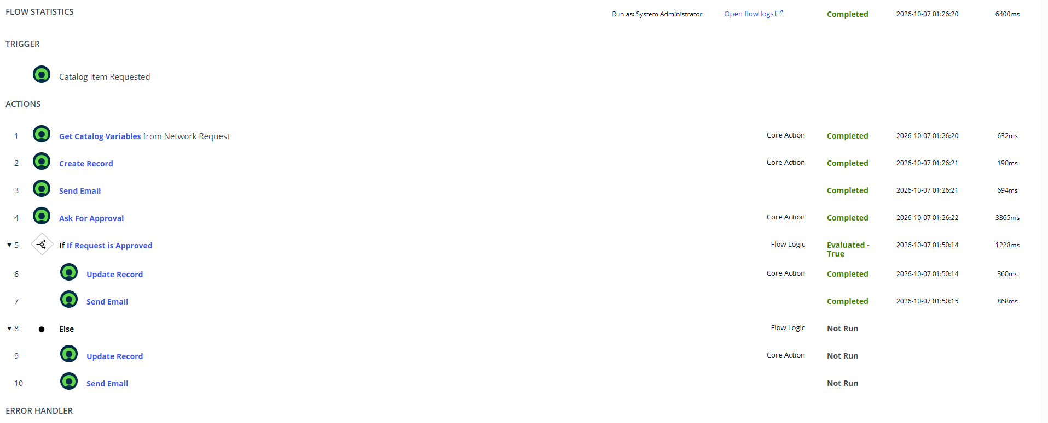

Purpose: Demonstrates that upon the manager clicking 'Approve', the flow automatically resumes, evaluates the Step 5 condition as True, and executes Steps 6 and 7 to completion.
What I Captured: In Flow Execution Details after approving the request, I refreshed the execution view and captured the updated trace showing overall Flow State = Completed, Step 4 completed (green checkmark), Step 5 evaluated as True, and Steps 6 (Update Record to Approved) and 7 (Send Approval Email) successfully completed with green checkmarks.

6. Stage 5: Data Persistence, Governance & Notification Verification
Finally, I verified that submitted requests were saved to the database, linked to approval records, and sent milestone notifications.
Steps I followed:
- I navigated to Database Tables ( u_database_table.list ) and verified that a record with the prefix NETDB (e.g., NETDB0001001 ) was generated with State = Awaiting Approval.
- I opened sysapproval_approver_list.do to verify that an approval task linked to the NETDB record was assigned to the approving manager.
- I simulated the approval action, which triggered the flow to update the table state to Approved.
- I navigated to System Logs > Emails ( sys_email.list ) to verify that outbound SMTP messages were generated and queued for both the initial acknowledgment and approval confirmation.
- I verified table-level Access Control Lists (ACLs) to ensure that regular requesters only have read access to their own tickets, while administrators maintain write access.

Screenshot 10: Database Tables Record View (u_database_tables)

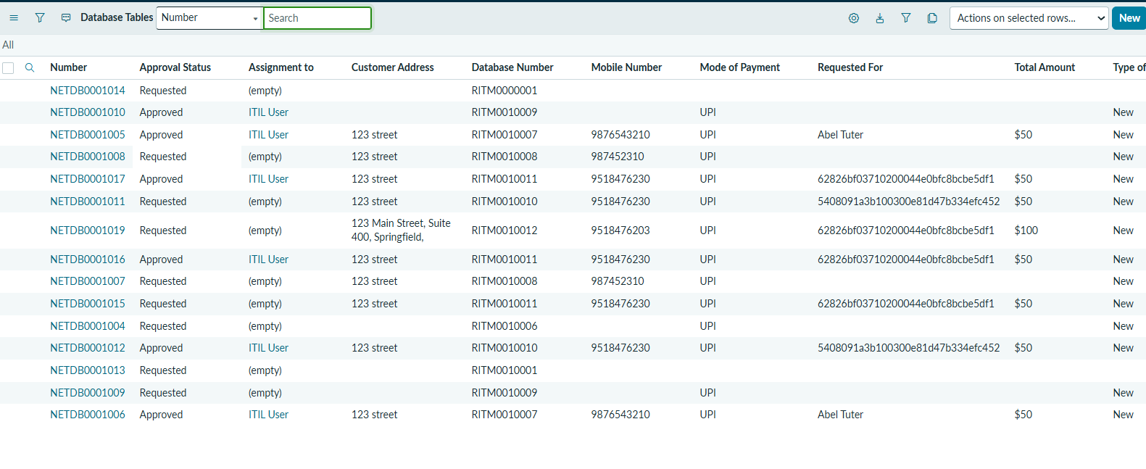

Purpose: Validates custom persistence and auto-numbering generation in the backend table.
What I Captured: I opened the generated record in u_database_table.list and captured the form displaying the auto-numbered NETDB key (e.g., NETDB0001001 ), State ('Awaiting Approval'), contact fields, and payment parameters.

Screenshot 11: Approval List & Approver View (sysapproval_approver)

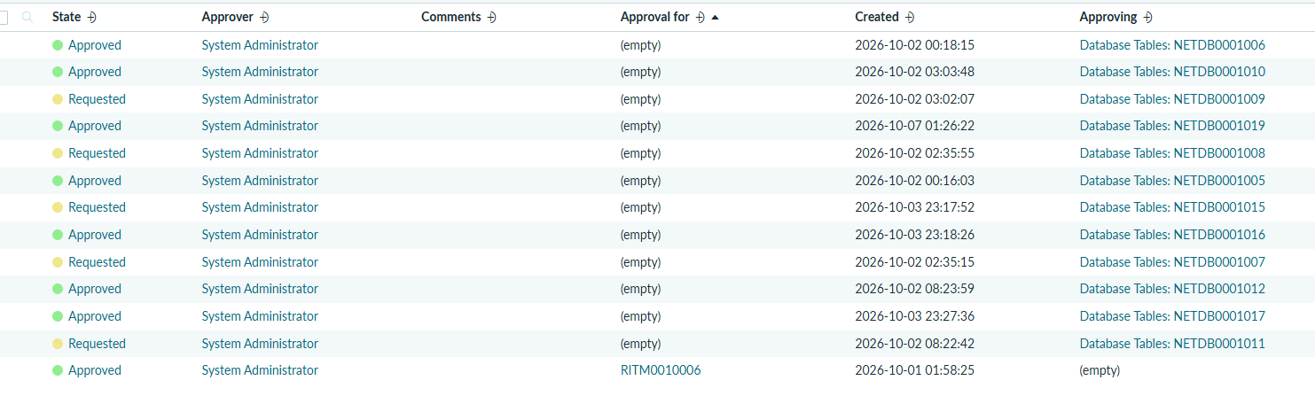

Purpose: Proves governance integration linking the custom table to the platform approval engine.
What I Captured: I opened sysapproval_approver_list.do and captured the approval record showing Approval for = NETDB0001001 , Approver = System Administrator, and State = Requested (or Approved).

Screenshot 12: Outbound Email Notification Verification (sys_email)
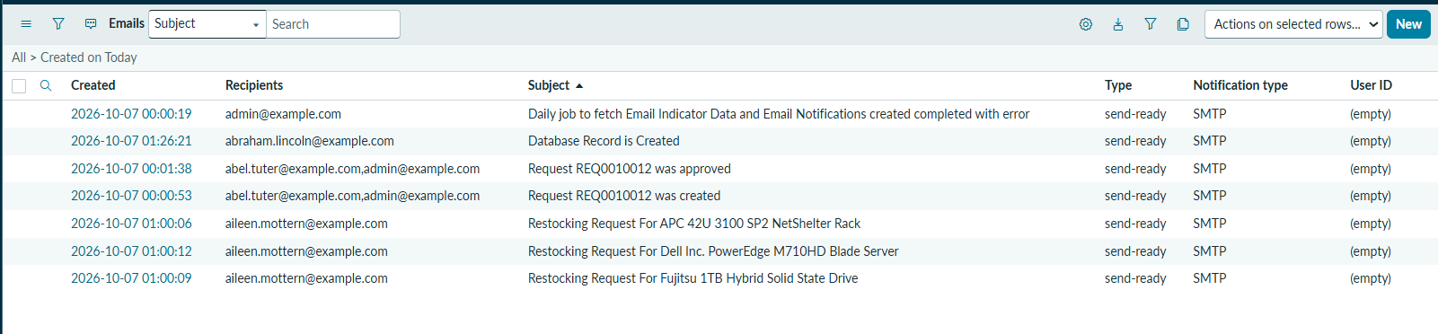

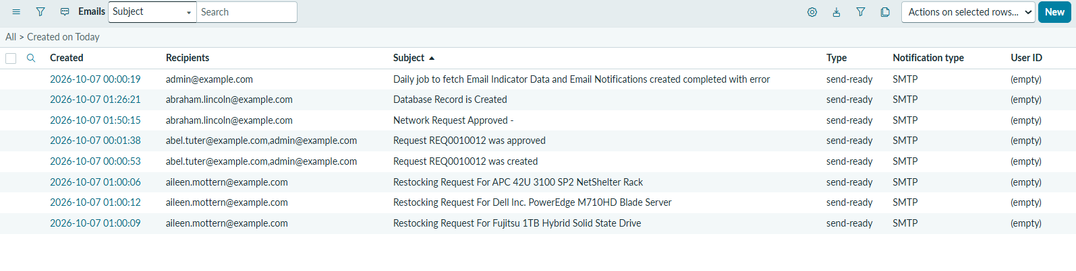

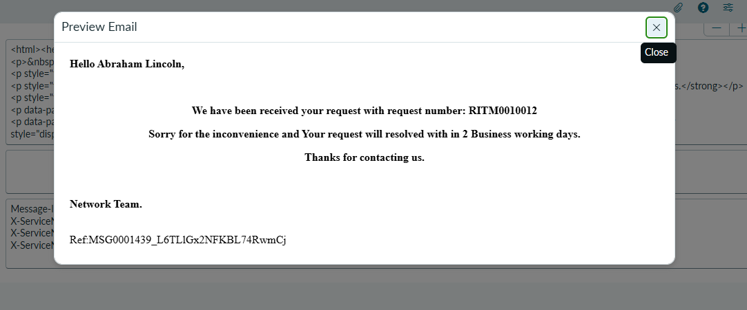

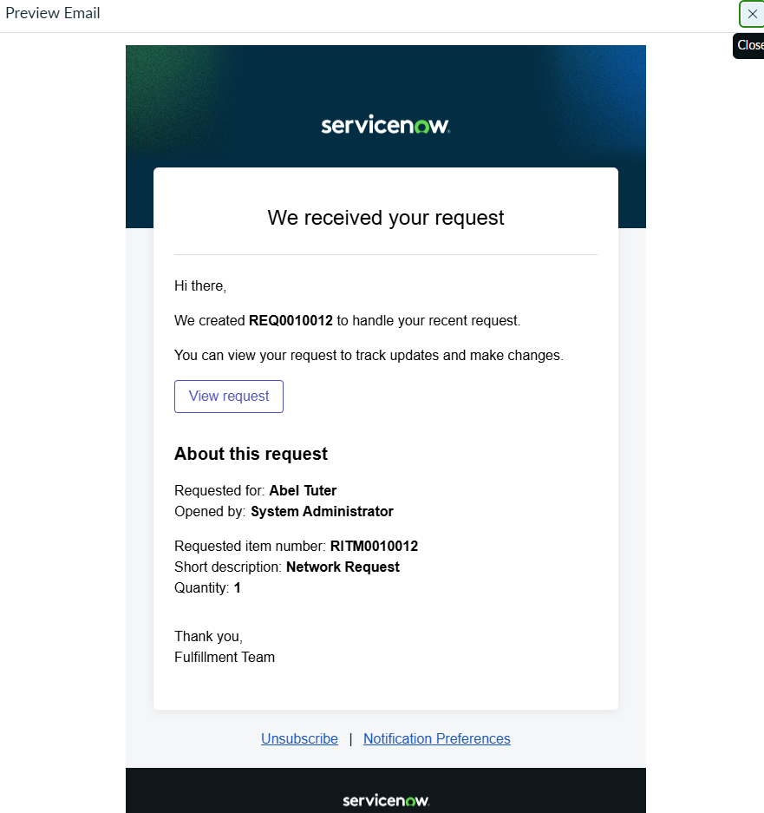

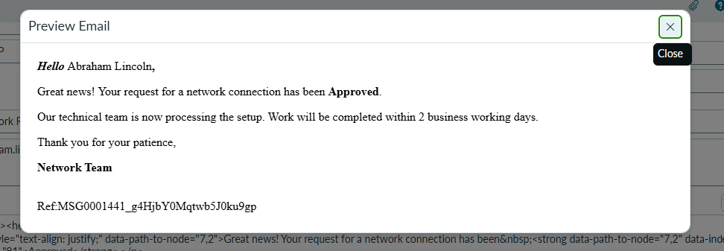

Purpose: Validates automated communications dispatching receipt confirmation to the user.
What I Captured: I opened System Logs > Emails ( sys_email.list ), located the sent message, and captured the email record showing recipient address, subject ('Network Request Received - Ref: NETDB...'), and body content.

Screenshot 13: Access Control Lists (ACL) Security Configuration
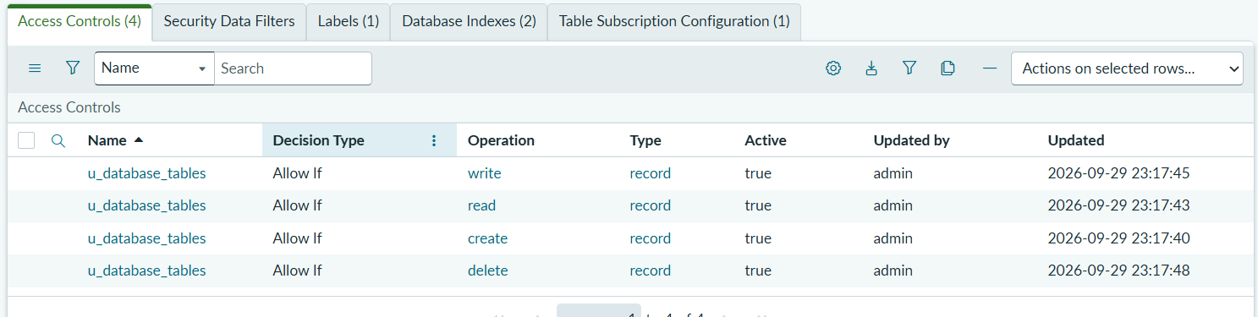

Purpose: Proves role-based access control and security rules enforced on the custom table.
What I Captured: I navigated to the table's Access Controls related list and captured the active ACL rules ( u_database_table create, read, write) showing enforced role permissions

7. Conclusion & Project Retrospective
By following this structured, step-by-step implementation, I successfully automated the entire network request management process within ServiceNow. Creating the custom table Database Tables ( u_database_table ) gave me complete control over the data schema and auto-numbering using the prefix NETDB, while the Catalog UI Policies guaranteed that requesters only fill in necessary, relevant details.
Using Flow Designer allowed me to establish an enterprise-grade approval and notification workflow without writing brittle custom scripts. Requesters now benefit from an intuitive self-service portal with instant email updates, managers have transparent approval controls, and all operations are securely logged for auditability. Overall, this project shows how native low-code tools in ServiceNow can transform slow, manual IT processes into fast, reliable, and auditable automated workflows.

